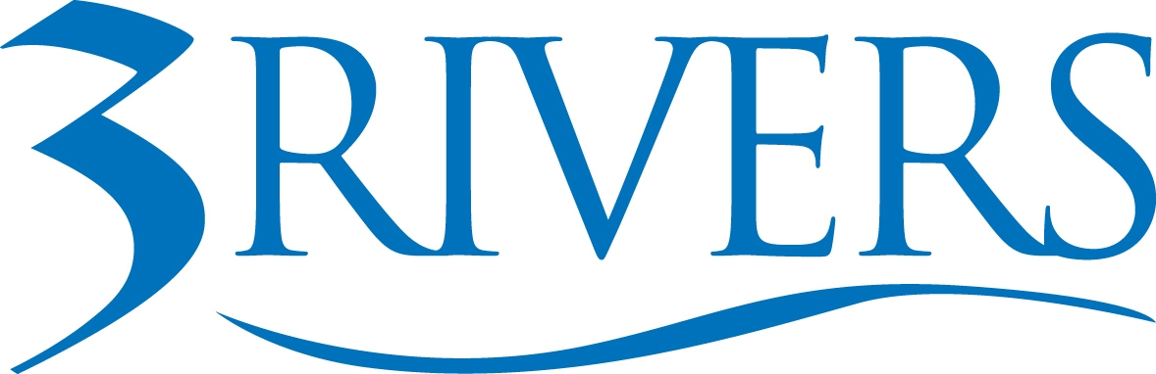 ***MEDIA ALERT***
Date: October 13, 2025
Contact: Simone LeClear
AVP of Marketing
Phone: +1(260) 418-4829
Email: sleclear@trfcu.org

For Immediate Release

3Rivers Credit Union Employees to Spend Columbus Day Volunteering in the Community
FORT WAYNE, IN –3Rivers Federal Credit Union will celebrate Columbus Day with a planned day of service on Monday, October 13. The branches will be closed in observance of the holiday, and over 350 of 3Rivers’ team members will be spending their day off volunteering in the community at 35 non-profit organizations in the region. Fort Wayne locations include an onsite panel build for Habitat for Humanity at 3Rivers headquarters on Lima Road, Community Harvest Food Bank, Fort Wayne Zoo, Fort Wayne Animal Care & Control, Ronald McDonald House, Blue Jacket, Blessings in a Backpack, Giving Gardens, Homebound Meals Inc., New Haven Parks Department, Bad Girls Club, and Soarin Hawk Raptor Rehabilitation.

Other locations in northeast Indiana and Ohio include: Bluffton Parks Department, Common Grace Ministry of Kendallville, Chain O’Lakes State Park, and DeKalb County Humane Society, Women in Transition Shelter of Angola.

In 3Rivers Central Indiana region, team members are volunteering with Nettle Creek Community Coalition of Hagerstown, Richmond Parks Department, East Central REHUB, Habitat 4 Humanity (Muncie), Girls Inc. Of Richmond, and Turn Away No Longer of Anderson.

This is the 11th year the credit union has observed a federal holiday with a day of service to the community. This is the largest day of service to date, with more volunteers and more community organizations, and is just part of the credit union’s ongoing community engagement commitments.

“Giving back to our community – both in time and financial support – is at the heart of our cooperative,” says Don Cates, President & CEO of 3Rivers. “On a day when we’d otherwise be closed for business, our team is committed to making an impact in our region, providing over 1,500 collective hours of paid volunteer work at local organizations. In our culture of giving back, Team3 values the time we get to address the diverse needs of the community and helping others connect with those resources.”
To set up photos or interviews, please contact Simone LeClear at 260.418.4829.

About 3Rivers: Since 1935, 3Rivers Federal Credit Union has been empowering their community to achieve financial wellness by offering personalized service, tools, and education. The member-owned, not-for-profit cooperative has $2.3 billion in assets, more than 112,000 members, 24 branches, and nearly 500 employees. 3Rivers offers a wide range of financial solutions, in addition to trustworthy, lifelong guidance and relationships. For more information, visit 3riversfcu.org.

